Mobile Application Lab Exercise 5-A
Now let’s to add a menu to a Mobile App by following the steps below;

- Open Android Studio and create a new Mobile App called MyMenuApp, and make sure you are selecting JAVA programming language.
- Wait until the Mobile App completed its settings
- Open the file activity_main.xml in design mode, and you will see a single TextView component with Hello World! Message.
- Add a new sub-folder called menu under res folder of your application. By clicking the right-hand side of the mouse on res folder and then select Android Resource Directory (see below).
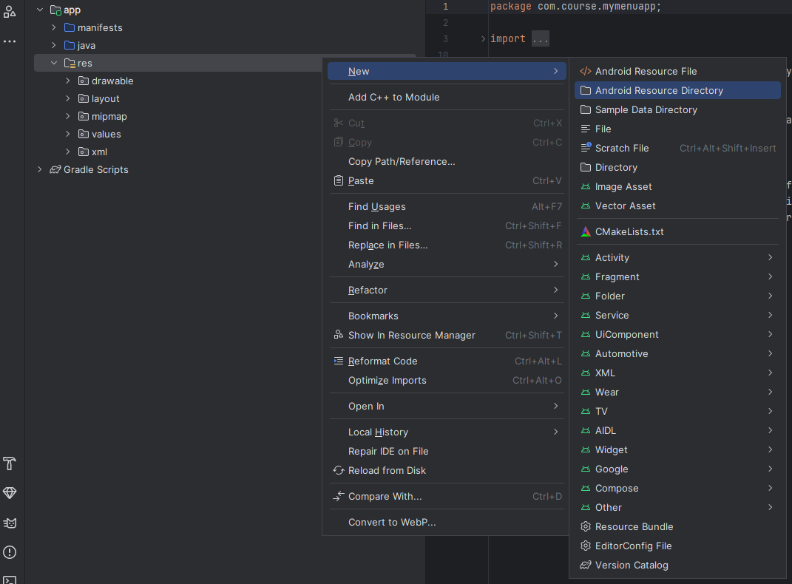
Then select the option menu from Resource type drop list (see below), and click Ok
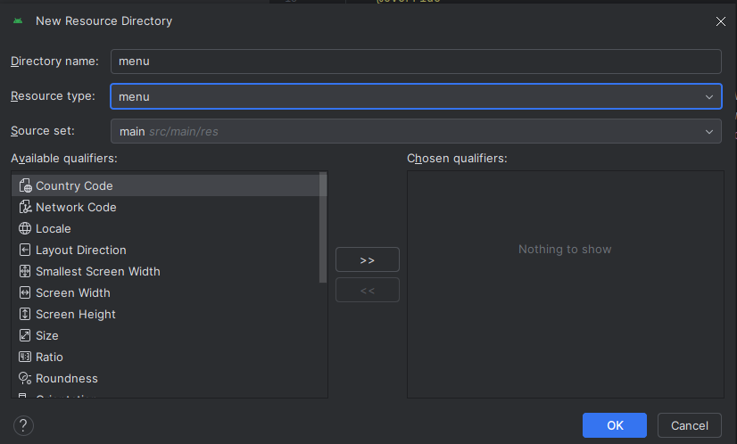
Now, click the right button of the mouse on the menu folder, then select Menu Resource File option (see below).
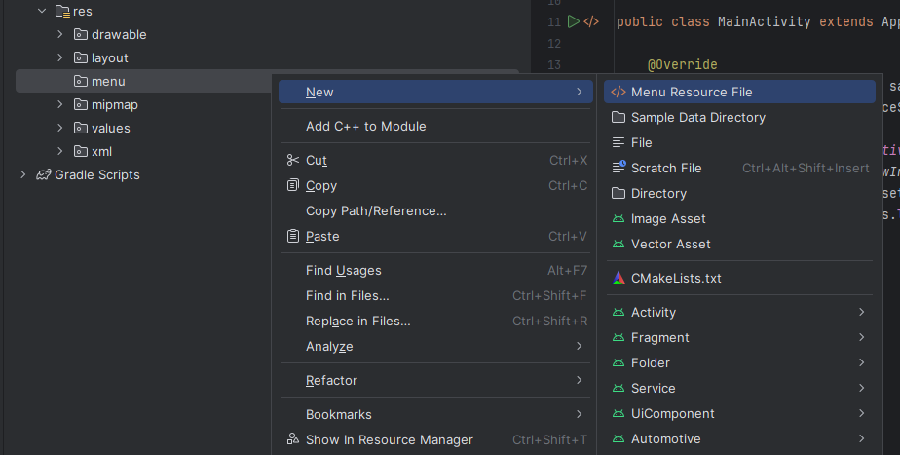
Add the file name as menu.xml and click OK (see below)
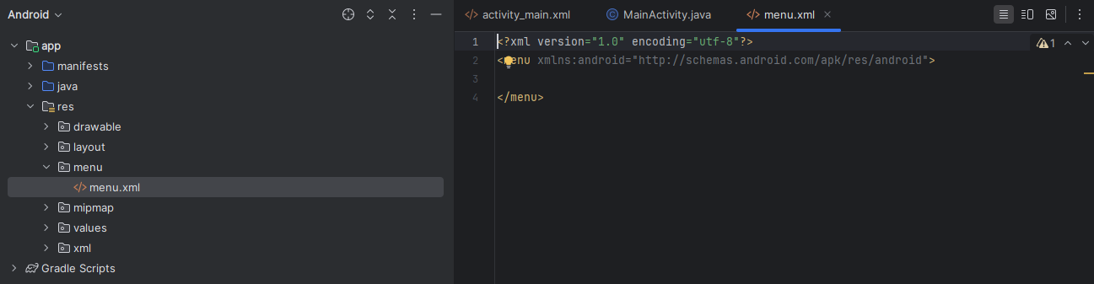
Add the following code in menu.xml file
<?xml version="1.0" encoding="utf-8"?>
<menu xmlns:android="http://schemas.android.com/apk/res/android">
<item
android:id="@+id/item1"
android:enabled="true"
android:title="New"
android:visible="true" />
<item
android:id="@+id/item2"
android:title="Open" />
<item
android:id="@+id/item3"
android:enabled="true"
android:title="Delete"
android:visible="true" />
</menu>

Now, open the MainActivity.java file and import the following packages

import android.view.Menu;
import android.view.MenuItem;

and add the following code after onCreate() method
@Override
public boolean onCreateOptionsMenu(Menu menu) {
getMenuInflater().inflate(R.menu.menu, menu);
return true;
}

Also, you need to the following codes for menu options
@Override
public boolean onOptionsItemSelected(MenuItem item) {
int itemId = item.getItemId(); // get selected menu item's id
// check selected menu item's id and replace a Fragment Accordingly
if (itemId == R.id.item1) {
Toast.makeText(MainActivity.this,"You select Option 1",Toast.LENGTH_SHORT).show();
} else if (itemId == R.id.item2) {
Toast.makeText(MainActivity.this,"You select Option 2",Toast.LENGTH_SHORT).show();
} else if (itemId == R.id.item3) {
Toast.makeText(MainActivity.this,"You select Option 3",Toast.LENGTH_SHORT).show();
}
return true;
}

Now compile and run your application for testing

Mobile Application Lab Exercise 5-B

Now let’s to add a menu to a Mobile App by following the steps below;

- Open Android Studio and create a new Mobile App called MyMenu, and make sure you are selecting JAVA programming language.
- Wait until the Mobile App completed its settings
- Open the file activity_main.xml in design mode, and you will see a single TextView component with Hello World! Message.
- Add a new sub-folder called menu under res folder of your application. By clicking the right-hand side of the mouse on res folder and then select Android Resource Directory (see below).

Then select the option menu from Resource type drop list (see below), and click Ok

Now, click the right button of the mouse on the menu folder, then select Menu Resource File option (see below).

Add the file name as menu_example.xml and click OK (see below)
Add the following code in menu_example.xml file

<?xml version="1.0" encoding="utf-8"?>
<menu
xmlns:android="http://schemas.android.com/apk/res/android"
xmlns:app="http://schemas.android.com/apk/res-auto">
<item
android:id="@+id/send"
android:icon="@android:drawable/ic_menu_send"
android:title="send"
app:showAsAction="always" />
<item
android:id="@+id/gallery"
android:icon="@android:drawable/ic_menu_gallery"
android:title="gallery"
app:showAsAction="always" />
<item
android:id="@+id/call"
android:icon="@android:drawable/ic_menu_call"
android:title="call"
app:showAsAction="always" />
<item
android:id="@+id/calculator"
android:icon="@android:drawable/ic_menu_call"
android:title="calculator"
app:showAsAction="ifRoom" />
<item
android:id="@+id/exit"
android:icon="@android:drawable/ic_menu_call"
android:title="exit"
app:showAsAction="ifRoom" />
</menu>

Please click on Design to see the Menu UI

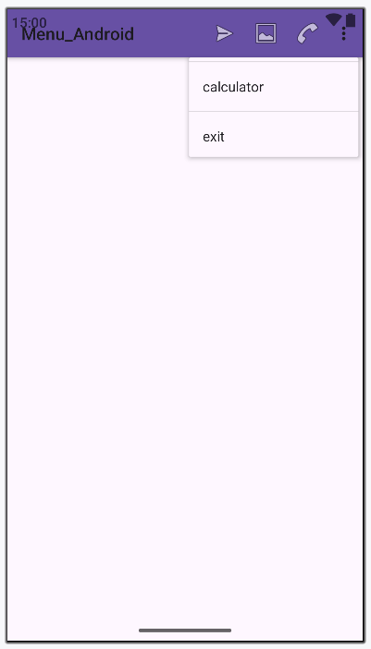

Now, open the MainActivity.java file and import the following packages

import android.view.Menu;
import android.view.MenuItem;
import android.widget.Toast;

and add the following code for onCreate() method and after the method

@Override
protected void onCreate(Bundle savedInstanceState) {
super.onCreate(savedInstanceState);

setContentView(R.layout.activity_main);

}
// Overriding onCreateOptionsMenu Method
@Override
public boolean onCreateOptionsMenu(Menu menu) {
getMenuInflater().inflate(R.menu.menu_example, menu);
return true;
}

// Overriding onOptionsItemSelected Method
@Override
public boolean onOptionsItemSelected(MenuItem item) {

int id=item.getItemId();
if (id == R.id.send) {
Toast.makeText(getApplicationContext(),
"Shows share icon", Toast.LENGTH_SHORT).show();
return true;
}else if (id==R.id.gallery) {
Toast.makeText(getApplicationContext(),
"Shows image icon", Toast.LENGTH_SHORT).show();
return true;
}else if (id==R.id.call) {
Toast.makeText(getApplicationContext(),
"Shows call icon", Toast.LENGTH_SHORT).show();
return true;
}else if (id == R.id.calculator) {
Toast.makeText(getApplicationContext(),
"Calculator menu", Toast.LENGTH_SHORT).show();
return true;
}else if (id== R.id.exit) {
finish();
return true;
}
return super.onOptionsItemSelected(item);
}
}

Now compile and run your application for testing

Mobile Application Lab Exercise 5-C
Now let’s to Create an android application to display different Dialog Boxes by following the steps below;

- Open Android Studio and create a new Mobile App called Mydialog, and make sure you are selecting JAVA programming language.
- Wait until the Mobile App completed its settings
- Open the file activity_main.xml in design mode, and you will see a single TextView component with Hello World! Message. Delete the TextView component.
- Open the activity_main.xml file
- Add the following code

<?xml version="1.0" encoding="utf-8"?>
<androidx.constraintlayout.widget.ConstraintLayout xmlns:android="http://schemas.android.com/apk/res/android"
xmlns:app="http://schemas.android.com/apk/res-auto"
xmlns:tools="http://schemas.android.com/tools"

android:layout_width="match_parent"
android:layout_height="match_parent"
>

<LinearLayout
android:layout_width="match_parent"
android:layout_height="wrap_content"
android:orientation="vertical"
app:layout_constraintTop_toTopOf="parent"
app:layout_constraintBottom_toBottomOf="parent"
app:layout_constraintStart_toStartOf="parent"
app:layout_constraintEnd_toEndOf="parent"
>

<Button
android:layout_width="wrap_content"
android:layout_height="wrap_content"
android:layout_gravity="center"
android:onClick="Customdailog"
android:text="CUSTOM DIALOG" />

<Button
android:layout_width="wrap_content"
android:layout_height="wrap_content"
android:layout_gravity="center"
android:onClick="AlertDialog"
android:text="ALERT DIALOG" />

<LinearLayout
android:layout_width="match_parent"
android:layout_height="wrap_content"
android:orientation="horizontal">

<Button
android:layout_width="wrap_content"
android:layout_height="wrap_content"
android:onClick="datepickerdailog"
android:text="Date Picker Dailog" />

<EditText
android:id="@+id/datepicker"
android:layout_width="match_parent"
android:layout_height="wrap_content"
android:editable="false" />
</LinearLayout>

<LinearLayout
android:layout_width="match_parent"
android:layout_height="wrap_content"
android:orientation="horizontal">

<Button
android:layout_width="wrap_content"
android:layout_height="wrap_content"
android:onClick="timepickerdailog"
android:text="Time Picker Dailog" />

<EditText
android:id="@+id/timepicker"
android:layout_width="match_parent"
android:layout_height="wrap_content"
android:editable="false" />
</LinearLayout>

<Button
android:layout_width="wrap_content"
android:layout_height="wrap_content"
android:layout_gravity="center"
android:onClick="indeterminent"
android:text="Indeterminant Progress Dailog" />

<Button
android:layout_width="wrap_content"
android:layout_height="wrap_content"
android:layout_gravity="center"
android:onClick="determinent"
android:text="Determinant Progress dailog" />
</LinearLayout>
</androidx.constraintlayout.widget.ConstraintLayout>

Create a new xml file called customdialog.xml by clicking on right button of your mouse on layout folder and under res folder and select New Resource File option (see below)

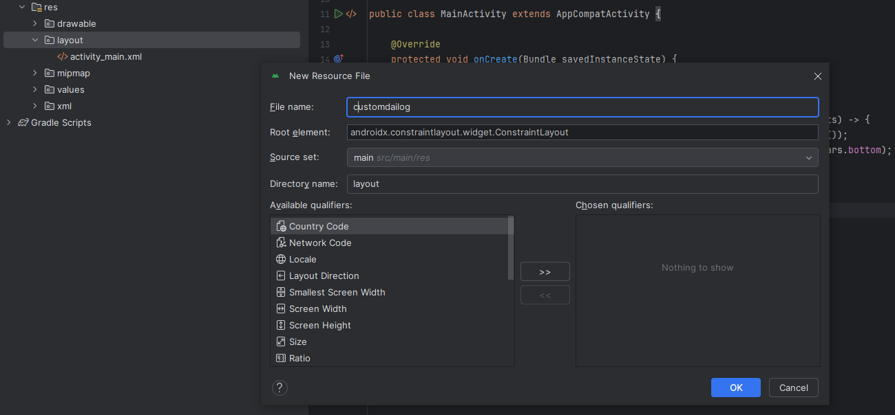
Open customdialog.xml file and add the following codes
<?xml version="1.0" encoding="utf-8"?>
<LinearLayout
xmlns:android="http://schemas.android.com/apk/res/android"
android:orientation="vertical"
android:layout_width="match_parent"
android:layout_height="match_parent">

<TextView
android:layout_width="match_parent"
android:layout_height="wrap_content"
android:text="Are You Sure To Exit"
android:textSize="20sp" />

<LinearLayout
android:layout_width="match_parent"
android:layout_height="wrap_content"
android:orientation="horizontal">
<Button
android:layout_width="0dp"
android:layout_height="match_parent"
android:layout_weight="0.2"
android:id="@+id/btn_yes"
android:text="Yes"/>

<TextView
android:layout_width="0dp"
android:layout_height="match_parent"
android:layout_weight="0.6" />

<Button
android:layout_width="0dp"
android:layout_height="match_parent"
android:layout_weight="0.2"
android:text="No"
android:id="@+id/btn_no"/>
</LinearLayout>
</LinearLayout>

Now, open MainActivity.java, and import the following packages
import android.os.Bundle;
import android.view.View;
import android.widget.Button;
import android.widget.DatePicker;
import android.widget.EditText;
import android.widget.TimePicker;
import android.app.DatePickerDialog;
import android.app.Dialog;
import android.app.ProgressDialog;
import android.app.TimePickerDialog;
import android.content.Context;
import android.content.DialogInterface;
import android.icu.util.Calendar;
import android.os.Vibrator;
import java.sql.Time;
import androidx.appcompat.app.AlertDialog;

Then add the following java codes
public class MainActivity extends AppCompatActivity {

protected void onCreate(Bundle savedInstanceState) {
super.onCreate(savedInstanceState);
setContentView(R.layout.activity_main);
}

public void Customdailog(View view){
final Dialog d=new Dialog(MainActivity.this);
d.setTitle("Message");
d.setContentView(R.layout.customdailog);
d.show();
Button yes_btn=(Button)d.findViewById(R.id.btn_yes);
Button no_btn=(Button)d.findViewById(R.id.btn_no);
yes_btn.setOnClickListener(new View.OnClickListener() {
@Override
public void onClick(View view) {
d.dismiss();
System.exit(0);
}
});
no_btn.setOnClickListener(new View.OnClickListener() {
@Override
public void onClick(View view) {
d.dismiss();
}
});
}

public void AlertDialog(View view){
AlertDialog.Builder builder=new AlertDialog.Builder(this);
builder.setTitle("Message");
builder.setMessage("Are You Suer To Exit");
builder.setIcon(R.mipmap.ic_launcher_round);
AlertDialog.OnClickListener listener= new AlertDialog.OnClickListener() {
@Override
public void onClick(DialogInterface dialogInterface, int which) {
if(which== dialogInterface.BUTTON_POSITIVE){
dialogInterface.dismiss();
finish();
}else if(which== dialogInterface.BUTTON_NEGATIVE) {
dialogInterface.dismiss();
}
}
};
builder.setPositiveButton("YES",listener);
builder.setNegativeButton("NO",listener);
builder.show();
}

public void datepickerdailog(View view) {
DatePickerDialog.OnDateSetListener listener= new
DatePickerDialog.OnDateSetListener() {
// @Overrid
public void onDateSet(DatePicker datePicker, int year, int monthofyear, int dayofmonth) {

EditText et=(EditText)findViewById(R.id.datepicker);
et.setText(dayofmonth + "-" + monthofyear + "-" + year);
}
};

DatePickerDialog dpd=new
DatePickerDialog(MainActivity.this, listener,2020,4,20);
dpd.show();
}

public void timepickerdailog(View view){
java.util.Calendar cal=java.util.Calendar.getInstance();
final int hour=cal.get(java.util.Calendar.HOUR);
final int min=cal.get(java.util.Calendar.MINUTE);
TimePickerDialog tpd=new TimePickerDialog(this, new
TimePickerDialog.OnTimeSetListener() {

@Override
public void onTimeSet(TimePicker timePicker, int i, int i1) {
EditText editText2=(EditText)findViewById(R.id.timepicker);
editText2.setText(i + ":" + i1 );
}
},hour,min,false);
tpd.show();
}

public void indeterminent(View view){
ProgressDialog pdailog=new ProgressDialog(MainActivity.this);
pdailog.setTitle("Message");
pdailog.setMessage("Please Wait while page is loading");
pdailog.setIcon(R.mipmap.ic_launcher_round);
pdailog.setProgressStyle(ProgressDialog.STYLE_SPINNER);
pdailog.show();
}

public void determinent(View view){
ProgressDialog pDailog=new ProgressDialog(MainActivity.this);
pDailog.setTitle("Message");
pDailog.setMessage("Downloading");
pDailog.setIcon(R.mipmap.ic_launcher_round);
pDailog.setProgressStyle(ProgressDialog.STYLE_HORIZONTAL);
pDailog.show();
}
}

Now compile and run your application for testing

